INSTRUCTION PAGE i

Following is a template example of a health and safety audit that can be used in response to a situation where your employer considers you need to be vaccinated to undertake your role.

If you are an affected worker designated to be jabbed pursuant to the Covid-19 Public Health Response (Vaccinations) Order 2021 (Vaccination Order) then your employer is still obliged to conduct and health and safety audit and is obliged to consider alternative methods of working.

If you have been forwarded this dby a friend, family member or colleague then please go to https://voicesforfreedom.co.nz/resources to see the outline of the employment process, to get access to the other letter/s, and to get access to the employment webinars hosted by Voices For Freedom. There are alternative letters for other roles that have been mandate.
Disclaimer: It is a strict condition of reading and/or using this letter in any way you irrevocably agree that you are bound by the terms and conditions of this disclaimer. If you do not agree with the terms and conditions of this disclaimer, you are prohibited for reading and/or using this letter. Notwithstanding anything in this letter, the information set out in this letter is for general information only, and should not be construed as legal advice and/or health advice. No client-solicitor relationship is created whatsoever. Before taking any action based on this letter, you should consider your personal situation and seek professional legal advice. You acknowledge and agree that you were advised to take legal advice prior to using any information in this letter. If you use this letter and/or any information in the letter you acknowledge and agree that you have relied on your own judgement and initiative and not in reliance of anything else. The reader and/or user of this letter agrees to protect, indemnify, defend, and save harmless the author absolutely from and against any and all damages, claims, losses, demands, liabilities (including vicarious liability), injuries, suits, actions, judgements, costs, and expenses of any kind whatsoever (including reasonable legal fees) arising out of or in any way connected with this letter and the information contained within. Any person and/or persons that shares this letter without this disclaimer accepts full liability for any damage whatsoever caused.
If you are sharing this document with others, you acknowledge and agree that you are prohibited from removing this disclaimer. The disclaimer may only be removed once the letter is ready to be sent by the person sending it. You are also prohibited from amending the letter other than the sections identified for you to add to and you acknowledge and agree to this. If, however, you would like to use parts of this letter in a letter that you draft yourself then you are permitted to do so. .

This health and safety analysis has been conducted for the [Workplace name] / [Role]
Introduction

There is a general duty under the Health and Safety at Work Act 2015 (HSW Act) to eliminate all risks to health and safety, and if risks cannot be eliminated, they must be minimised as far as is reasonably practical. Some of these duties are outlined in more detail in the Health and Safety at Work (General Risk and Workplace Management) Regulations 2016.

Health and safety risk assessments are a tool to assist an organisation to conduct a review of risks of injury or harm in the workplace. Health and safety risk assessments have significantly developed and simplified over time.

The structure for conducting a health and safety risk assessment is to first identify the Risk, assess the levels of that Risk in the given job/workplace and where required identify the Controls to manage and limit that Risk.
The following:
- Risk assessment matrix can be considered for any workplace risk;
- hierarchy of risk Controls can be considered for reducing as much as possible any risk.
1. | 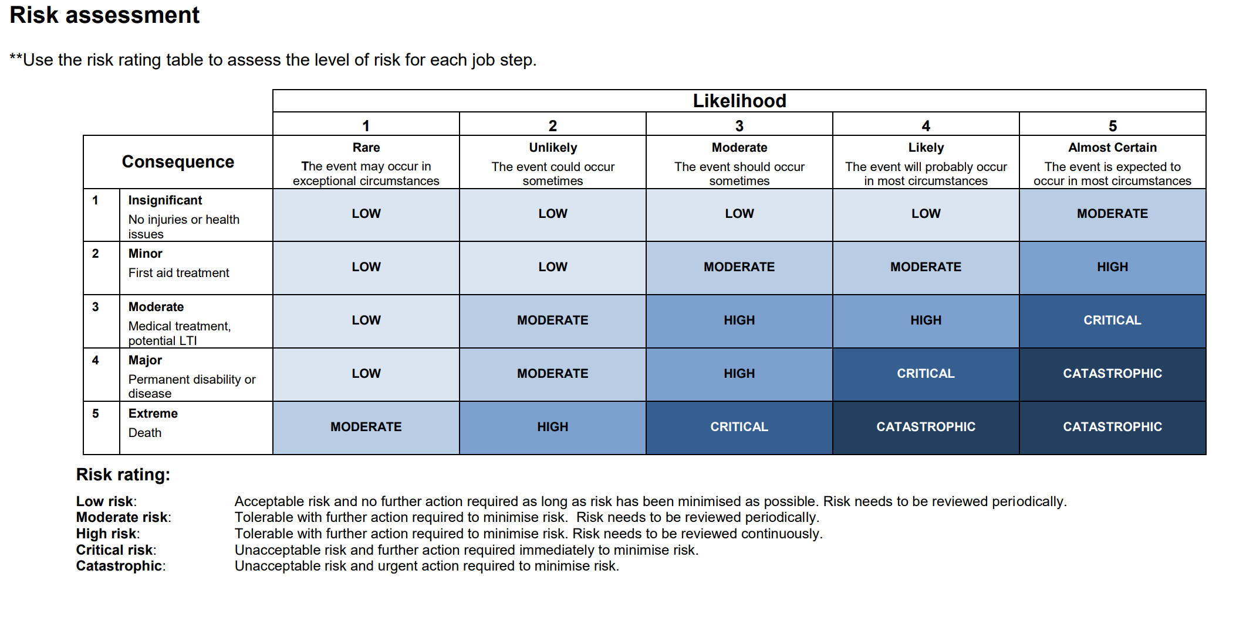
2. | 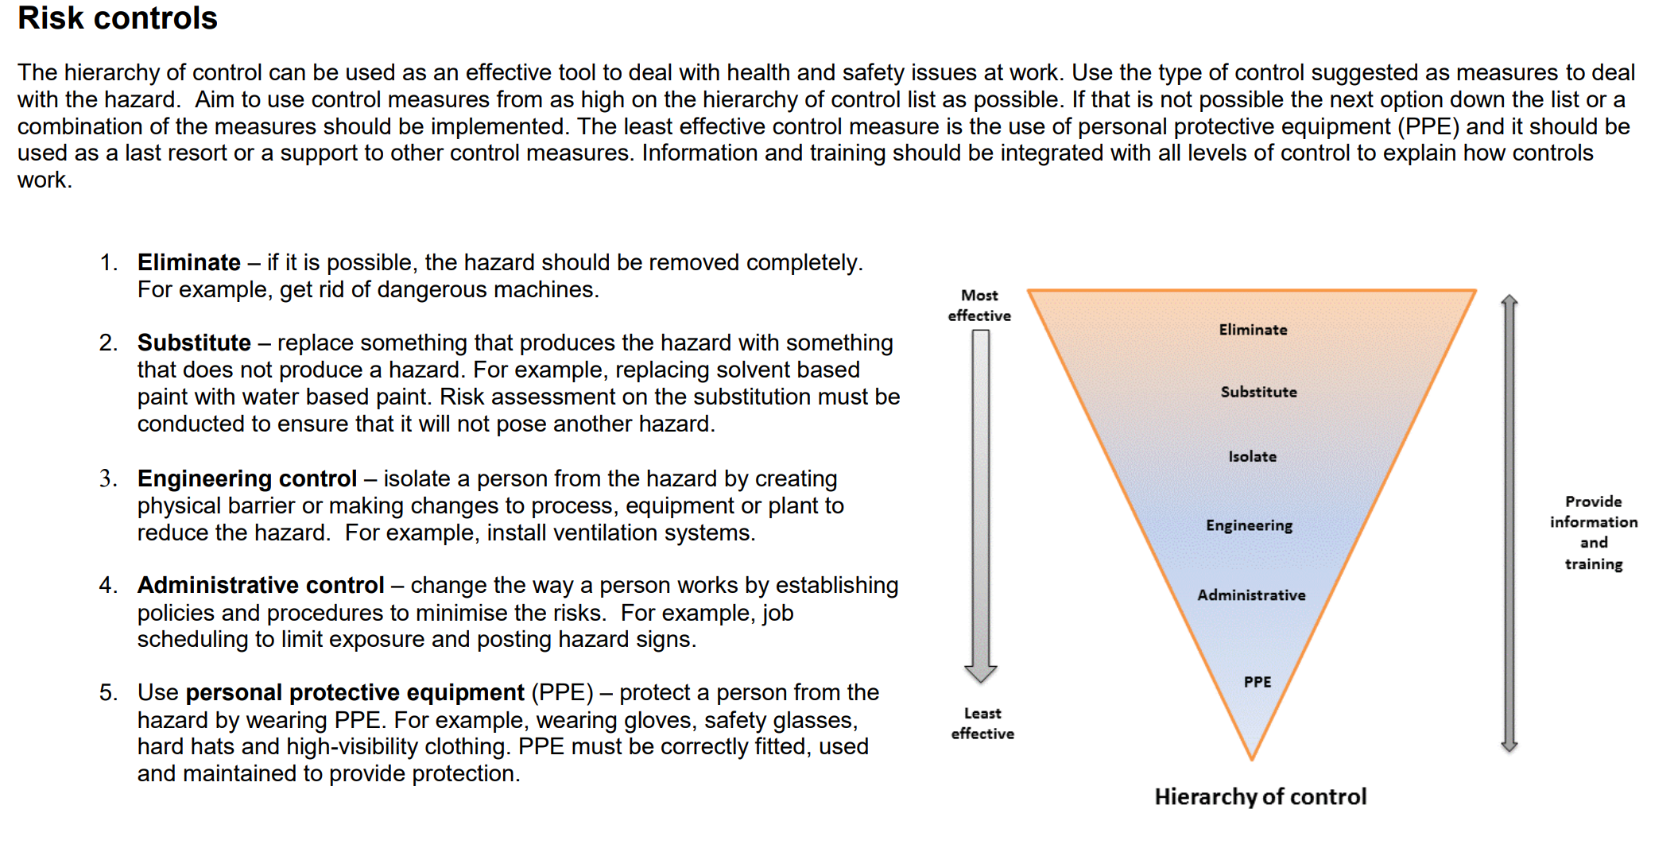

Evaluation regarding [workplace]’s current control measures
We cannot eliminate the risk of COVID-19, nor can we substitute our employee’s engagement with the public when providing services to the public, or when they are not at work.
With respect to the transmission and infection of Covid-19, the two top level control response to the management of the risk in provided by WorkSafe, elimination and substitution (the top two forms of control), are not applicable in this context.
That is because it is not possible to eliminate the risk of Covid-19, nor can we substitute our employee’s engagement with the public while providing essential services to the citizens of New Zealand, or for when they are not at work.
This means the next option for [workplace] to consider is the addition of engineering controls such as safety by design (screens etc.) and social distancing, practicing good hygiene, PPE, vaccination, to complement our current controls that are made up of public health measures, training, and personal protective equipment such as face mask use.

[Workplace] risk assessment
The following risk assessment follows WorkSafe NZ’s Hierarchy of Controls and applies all control measures in line with this hierarchy that [workplace] has in place to manage the risk of transmission and infection of COVID-19 in the workplace. It also demonstrates how we can further reduce the risk by additional control measure options.
There are six levels of control measures, the most effective being at the top of the hierarchy and the least effective is at the bottom:

The government has bought out the assessment tool
On 15 December 2021, the government bought out its risk assessment tool to determine whether prima facie vaccination of a specific role would be reasonable.
The questions asked are:
1. Is the worker carrying out work in an area that is less than 100 square metres? Yes / No
2. Is the worker able to maintain a one metre distance from other workers? Yes / No
3. Does the worker carry out work within one metre of others for more than 15 minutes at a time? Yes / No
4. Does the worker provide services to people the PCBU considers to be vulnerable? Yes / No
If the answer is “no” to at least two of the above, the government suggests it is not reasonable to require that employee to be vaccinated.
If the answer is “yes” to at least three of the above, the government considers it would be reasonable to require vaccination. In this instance, the risk of Covid-19 should be weighed against the risk of the vaccine to that individual in determining whether or not the business should require that individual to be vaccinated.
This risk assessment assists by incorporating the above questions in to the health and safety audit.
We have incorporated the questions into the risk and control tables below to assist in managing the risk or fortressing the controls.

1. RISK ANALYSIS
Description | Research | Application to role and Management of Risk
Risk analysis – identify and analyse the risk specific to the job/role
The RISK:  Covid-19 | For people under the age of 70 with no underlying health issues, the likelihood of dying from Covid-19 is nil to negligible with the average age of deaths being above 80 years. If a person does catch Covid-19, the chance of death overall is 0.28% or 0.0126% chance of death if under 65 with no underlying health conditions.  Since March 2020, NZ has had 11,260 cases of Covid-19 with 43 people dying with Covid-19. Some of these deaths may have been unrelated to Covid-19. This is over a 2 year period.  In 2017, over 200,000 people caught the flu and 871 people died of flu and pneumonia in NZ.  Since MIQ there have been 190,000 people stay in the facilities. Since that time there have only been 11,000 cases of Covid in NZ, including in MIQ. The main way of entry into NZ is via plane. If Covid-19 was as transmissible as described, then the cases would be much greater.  Only one tenth of cases are reported. Out of the reported cases, 13.8% are severe and 4.7% are critical. Particular risk factors which put people at higher risk are those individuals with cardiovascular disease, diabetes, chronic respiratory disease and hypertension.  There is no actual data or substantive information about the actual risks and effects of Covid-19 on any of government websites. All descriptions are generalities and supposition.  Government assessment tool, Q4: Does the worker provide services to people the PCBU considers to be vulnerable? | [Expand on whether your role one where you are exposed to or work with people vulnerable, namely those above 65 years with diabetes, lung disease, cancer, immunodeficiency, heart disease, hypertension, asthma, kidney disease, GI/Liver disease and obesity? | Review table 1 to rate your risk assessment.  If you do work with vulnerable people then your risk assessment may be:  Consequence 3. Medical treatment potential,  Likelihood 3. The event should occur sometimes = HIGH  If you do not work with vulnerable people, then your risk assessment may be:  Consequence 1. Insignificant  Likelihood 3. The event should occur sometimes = LOW TO MODERATE
Workplace transmission – anything specific to your role OR | Locate research and information on any transmission or spread specific to your job role. |  | Review table 1 to rate your Risk assessment specific to your role.
Workplace transmission - things to consider specific to the role in the workplace | Worksafe have identified questions to assist you with your risk to Covid-19 exposure:  - How many people does the employee carrying out that work come into contact with (very few = lower risk; many = higher risk)?  - How easy will it be to identify the people who the employee comes into contact with (easy to identify, such as co-workers = lower risk; difficult to identify, such as unknown members of public = higher risk)?  - How close is the employee carrying out the tasks in proximity to other people (two metres or more in an outdoor space = lower risk; close physical contact in an indoor environment = higher risk)?  - How long does the work require the employee to be in that proximity to other people (brief contact = lower risk; lengthy contact = higher risk)?  - Does the work involve regular interaction with people considered at higher risk of severe illness from COVID-19, such as people with underlying health conditions (little to none = lower risk; whole time = higher risk)?  - What is the risk of COVID-19 infection and transmission in the work environment when compared to the risk outside work (equal to outside work = lower risk; higher than outside work = higher risk)?  - Will the work continue to involve regular interaction with unknown people if the region is at a higher alert level (no = lower risk; yes = higher risk)?  https://www.worksafe.govt.nz/ | 1.  2.  3.  4.  5.  6.  7. | Review table 1 to rate your Risk assessment specific to your role.

2. CONTROLS
Description | Research | Controls applicable to role and Management of Risk
Consideration of possible Controls to manage Risk where required
What other controls could be put in place to reduce the risk (i.e., hygiene, PPE, social distancing, contact tracing)?
- Regular Testing of everyone (vaccinated and unvaccinated) | If Covid-19 is the risk, then regular testing of both vaccinated and unvaccinated people has to be the first and foremost response to know whether someone has Covid-19 and therefore can spread Covid-19.  It is necessary to determine those attending the workplace do not have Covid-19 to spread Covid-19.  Covid-19 is most infectious in the first two days before symptoms start and three days after.  The government has now confirmed on more than one occasion that those vaccinated can catch and spread Covid-19:  - 8 November 2021 "You can still get COVID-19 if you're vaccinated but the symptoms are likely to be very mild, or you may not have symptoms at all. This means that if you are vaccinated and get COVID-19, you may not realise and spread it to others".  - 18 November 2021: "When there is high COVID-19 vaccine coverage (i.e., above 80 percent of eligible people are fully vaccinated), transmission is more likely to occur from a vaccinated than an unvaccinated individual. As our vaccination numbers increase, we will see fewer cases but more of those cases will be in fully vaccinated people, meaning it is more likely transmission will occur from a vaccinated individual than an unvaccinated individual."  Testing is even more important as Covid-19 is most infectious in the first two days before they start showing symptoms and three days after they start showing symptoms.  Vaccinated and unvaccinated individuals have similar viral loads in communities with a high prevalence of the SARS-CoV-2 delta variant  Regular testing will ensure that those who have the virus even if they do not realise will be able to comply with the policy health and safety policy - whether vaccinated or unvaccinated. | Review table 2 to determine how best to manage the Risk using appropriate Controls.  The management of the risk of transmission and infection of COVID-19 is likely not able to be eliminated or substituted (the top two forms of control) in the hierarchy of controls provided by WorkSafe NZ and are therefore not applicable in this context.  We are unlikely to eliminate the risk of COVID-19, however we can reduce the risk as much as possible. The next option to consider is to isolate people from the risk of spread. To do that we need to identify those people that have Covid-19 before they enter into the workplace.  Based on the government's recent statements, those that are vaccinated and those that are not, both can catch and spread Covid-19. Therefore, testing of all employees is the only actual way to isolate the risk of Covid-19 from the workplace.  Other additional engineering controls such as screens and ventilation can also be considered along with administrative management and PPE (masks and hand sanitiser).
- Company health policy | Managing the spread of any virus has been a policy that the company has had in place.  The policy has always provided: Stay home if you are not well, do not return to work until you are well.  As there is testing for Covid-19, the policy need only be updated slightly: an individual that is unwell and experiencing symptoms listed on the Unite Against Covid-19 page should remain home and get tested, if positive to Covid-19, self-isolate for 14 days, do not return to work until you have a negative test and are feeling well.  The general policy should be updated for Covid-19, if it has not already.  This policy is applicable to all staff (vaccinated and unvaccinated). | Review table 2 to determine how best to manage the Risk using appropriate Controls. In the hierarchy of controls, administration level can be considered.  Expand on what your employer's health policy is and identify what further updates are required for Covid-19.  This is likely to be an administrative control in the Control table 2 above.  Expand
- Work outside | If working outdoors, the risk of transmission is much lower. | Review table 2 to determine how best to manage the Risk using appropriate Controls. In the hierarchy of controls, isolation control level can be considered.  Do you, or can you work out doors or with doors and windows wide open?  This is likely to be an isolation control in the Control table Isolation Control.  Expand
- Work Inside | The risk of transmitting a virus indoors is higher. The Company should consider ventilation options. These can reduce transmission up to 99.99%.  Improving ventilation within the workplace.  This will ensure that virus particles are not stagnant in the air.  Good ventilation can reduce the likelihood of contracting and spreading Covid-19 by 99.9% and should be explored.  Government assessment tool, Q1: Is the worker carrying out work in an area that is less than 100 square metres? | Review table 2 to determine how best to manage the Risk using appropriate Controls. In the hierarchy of controls, engineering and administrative control levels can be considered.  Do you, or can you work out doors or with doors and windows wide open.  This is likely to be an administrative control in the Control table Isolation Control.  Expand
- Social Distancing  <1m for >15mins | The government has identified that the work area, proximity to other people, and length of time in people's presence are all ways and means of reducing spread.  It is not clear whether social distancing assists, but is an easy measure to take in reducing the risk of the transmission of Covid-19.  Therefore, a work place that maintains a >1m distance and for >15 minutes per interaction is considered to reduce the risk of spread.  Therefore, office workspaces, check out operators, petrol pump attendants, waiting staff can all be managed to maintain these distances and reduce the time spent in people's presence.  However, if people adhered to control 1 and 2, this would reduce the need for social management.  Government assessment tool, Q2: Is the worker able to maintain a one metre distance from other workers?  Government assessment tool, Q3: Does the worker carry out work within one metre of others for more than 15 minutes at a time? | Review table 2 to determine how best to manage the Risk using appropriate Controls. In the hierarchy of controls, administrative control levels can be considered.  This is likely to be an administrative control in the Control table Isolation or Administrative Control.  Expand
- Face coverings inside | Where ventilation is not optimal in an indoor setting and if physical distancing is not possible, face coverings may be considered as a control.  This reduces the transmission of Covid-19, as droplets of moisture cannot escape from your mouth and are stopped by the face covering. | Review table 2 to determine how best to manage the Risk using appropriate Controls. In the hierarchy of controls, PPE control level can be considered.  This is likely to be an administrative control in the Control table is a PPE Control.  Expand
- Hygiene:  Hand sanitiser at the  entrance and around the  workplace | Ensuring personal hygiene can mean that if someone unknowingly has the virus, they can prevent the spread by ensuring that the virus is not spread by way of their hands. | Review table 2 to determine how best to manage the Risk using appropriate Controls. In the hierarchy of controls, PPE control level can be considered.  Proper and fulsome hand sanitising may reduce the spread of viruses.  This is likely to be an administrative control in the Control table is a PPE Control.  Expand
- Contact tracing | Contract tracing can be useful to identify those that have been in contact with an infected person.  However, contact tracing does not stop immediate spread, it only allows people to be identified once a person has been identified as infected.  Therefore, people may be carriers for days before, particularly where a person is asymptomatic.  Contact tracing can be useful in reducing transmission as all potentially affected individuals can be easily contacted and the spread contained.  If you have been in contact with a confirmed Covid-19 case, you should self isolate whether vaccinated or not and get tested. | Review table 2 to determine how best to manage the Risk using appropriate Controls. In the hierarchy of controls, administrative control level can be considered.  People who have been in contact with someone who has had a positive test can then readily be contacted.  This is likely to be an administrative control in the Control table Isolation or Administrative Control.  Expand
- Vaccinate the high risk | Both vaccinated and unvaccinated people could contract and transmit Covid-19.  Those who are at greater risk from Covid-19 should seriously consider vaccination and should be encouraged to do so.  95.5% of deaths are in those who are over the age of 65 and/or have an underlying medical condition.  These conditions include diabetes, lung disease, cancer, immunodeficiency, heart disease, hypertension, asthma, kidney disease, GI/Liver disease and obesity. | Vaccination is not a control that fits within the definition of the Control table. Therefore as a control, it needs to be considered how it may benefit the workplace.  Further, given the number of reported adverse reactions, it would seem that vaccination itself would require a separate, independent and fulsome health and safety risk audit for the purposes of understanding the risks versus benefits in our workplace.
- Vaccinate all staff | The Pfizer vaccine is a novel mRNA vaccine presently undergoing phase 3 human trials, which are not due to complete until May 2023 (at this stage), with data being made available a further 24 months thereafter (May 2025 at this stage).  The Pfizer vaccine only has provisional consent for use in New Zealand. Given that the Pfizer vaccine is still in trial, no medium or long term adverse health impacts are known and it is therefore not possible for individuals to give fully informed consent – a fundamental right codified in New Zealand's core and constitutional legislation.  Further, it has not yet been demonstrated that the Pfizer vaccine will either prevent infection or transmission of SARS-COV-2. Indeed, evidence from outside of New Zealand confirms that the Injection does not have a long lasting effect on preventing infection or transmission (eg United States, Israel, United Kingdom, Singapore, Massachusetts).  Of great concern is the significant adverse events being reported globally and locally following vaccinations with the Pfizer Injection. These include death, anaphylaxis, blood clots and related complications, leaky blood vessels and related complications, heart problems (myocarditis and pericarditis), neurological disorders, autoimmune disorders, other chronic and inflammatory conditions, blindness and deafness, infertility, foetal damage, miscarriage and stillbirth, and Covid-19. Pfizer itself has identified risks in its Risk Management Plan.  There is currently no evidence that the application of a pathway based solely on vaccination status is justified. In fact, some of the most vaccinated countries in the world are facing new waves. | Vaccination is not a control that fits within the definition of the Control table. Therefore as a control, it needs to be considered how it may benefit the workplace.  Further, given the number of reported adverse reactions, it would seem that vaccination itself would require a separate, independent and fulsome health and safety risk audit for the purposes of understanding the risks versus benefits in our workplace.

https://www.legislation.govt.nz/regulation/public/2021/0418/latest/LMS616575.html
https://ourworldindata.org/mortality-risk-covid;
https://swprs.org/studies-on-covid-19-lethality/#age
https://www.worldometers.info/coronavirus/coronavirus-death-rate/
As at 27 November 2021: https://www.google.com/search?q=covid+numbers+nz+latest&rlz=1C1GCEV_enNZ948NZ948&oq=covid+numbers+nz&aqs=chrome.2.69i57j0i512l9.6766j0j7&sourceid=chrome&ie=UTF-8
https://www.health.govt.nz/our-work/diseases-and-conditions/covid-19-novel-coronavirus/covid-19-data-and-statistics/covid-19-current-cases
https://www.nzherald.co.nz/nz/nz-is-still-flu-free-heres-the-problem-with-that/MMHFMFUXHIN7Y32NGH4TISOIA4/#:~:text=Normally%20each%20year%2C%20more%20than,than%20the%20annual%20road%20toll
https://figure.nz/chart/jFmzkvRLFLUeU0Zd-oJ3vB3ZU59yoLm7d
https://www.worldometers.info/coronavirus/coronavirus-death-rate/
https://www.worldometers.info/coronavirus/coronavirus-symptoms/#mild
https://jamanetwork.com/journals/jamainternalmedicine/fullarticle/2783099 ; https://www.health.govt.nz/our-work/diseases-and-conditions/covid-19-novel-coronavirus/covid-19-health-advice-public/about-covid-19/covid-19-what-we-know-about-infection-and-immunity
Updated 8 November 2021 https://www.health.govt.nz/our-work/diseases-and-conditions/covid-19-novel-coronavirus/covid-19-health-advice-public/assessment-and-testing-covid-19/covid-19-saliva-testing
https://web.archive.org/web/20211118055613/https://www.health.govt.nz/system/files/documents/pages/ministry_of_health_position_statement_on_the_management_of_unvaccinated_individuals_in_healthcare_settings_.pdf
https://jamanetwork.com/journals/jamainternalmedicine/fullarticle/2783099 ; https://www.health.govt.nz/our-work/diseases-and-conditions/covid-19-novel-coronavirus/covid-19-health-advice-public/about-covid-19/covid-19-what-we-know-about-infection-and-immunity
https://www.medrxiv.org/content/10.1101/2021.07.31.21261387v1.full-text
https://covid19.govt.nz/health-and-wellbeing/covid-19-testing/get-tested-for-covid-19/#types-of-tests-for-covid-19
https://www.health.govt.nz/our-work/diseases-and-conditions/covid-19-novel-coronavirus/covid-19-health-advice-public/about-covid-19/covid-19-what-we-know-about-infection-and-immunity ; https://www.medrxiv.org/content/10.1101/2021.09.28.21264262v2.full
https://covid19.govt.nz/health-and-wellbeing/protect-yourself-and-others-from-covid-19/stay-home-if-youre-sick/
https://www.health.govt.nz/our-work/diseases-and-conditions/covid-19-novel-coronavirus/covid-19-health-advice-public/about-covid-19#spreads https://covid19.govt.nz/health-and-wellbeing/about-covid-19/what-is-covid-19/#how-covid-19-spreads
https://www.activepure.com/
https://covid19.govt.nz/health-and-wellbeing/protect-yourself-and-others-from-covid-19/maintain-good-hygiene/
https://www.activepure.co.nz/
https://www.health.govt.nz/our-work/diseases-and-conditions/covid-19-novel-coronavirus/covid-19-health-advice-public/about-covid-19#spreads
https://covid19.govt.nz/health-and-wellbeing/protect-yourself-and-others-from-covid-19/maintain-physical-distancing/
https://covid19.govt.nz/health-and-wellbeing/protect-yourself-and-others-from-covid-19/wear-a-face-covering/
https://covid19.govt.nz/health-and-wellbeing/protect-yourself-and-others-from-covid-19/maintain-good-hygiene/
https://covid19.govt.nz/health-and-wellbeing/protect-yourself-and-others-from-covid-19/keep-track-of-where-youve-been/
https://covid19.govt.nz/health-and-wellbeing/contact-tracing/contacts-of-someone-who-has-covid-19/
https://www.worldometers.info/coronavirus/coronavirus-death-rate/
https://www.pfizer.com/science/coronavirus/vaccine/about-our-landmark-trial
Being 24 months from the "primary study completion date" https://www.pfizer.com/science/clinical-trials/trial-data-and-results/data-requests
https://www.health.govt.nz/our-work/diseases-and-conditions/covid-19-novel-coronavirus/covid-19-vaccines/covid-19-assessing-and-approving-vaccines
Vaccine Breakthrough Infections: The Possibility of Getting COVID-19 after Getting Vaccinated (cdc.gov); https://link.springer.com/article/10.1007/s10654-021-00808-7
https://www.medrxiv.org/content/10.1101/2021.08.24.21262415v1; https://www.eurosurveillance.org/content/10.2807/1560-7917.ES.2021.26.39.2100822
SARS-CoV-2 variants of concern and variants under investigation (publishing.service.gov.uk)
https://www.moh.gov.sg/news-highlights/details/updates-to-healthcare-protocols-and-implementation-of-vaccine-booster-strategy_10Sep2021
https://www.cdc.gov/mmwr/volumes/70/wr/mm7031e2.htm
United Kingdom: Coronavirus (COVID-19) vaccine adverse reactions - GOV.UK (www.gov.uk); Europe: European database of suspected adverse drug reaction reports (adrreports.eu); https://dap.ema.europa.eu/analytics/saw.dll?PortalPages&PortalPath=%2Fshared%2FPHV%20DAP%2F_portal%2FDAP&Action=Navigate&P0=1&P1=eq&P2=%22Line%20Listing%20Objects%22.%22Substance%20High%20Level%20Code%22&P3=1+42325700 United States: Welcome (openvaers.com)
https://www.medsafe.govt.nz/COVID-19/vaccine-report-overview.asp
https://www.medsafe.govt.nz/COVID-19/Comirnaty-RMP.pdf
Ministry of Health Position Statement, page 2, bullet 4.

