INSTRUCTION PAGE i

Following is a template letter that can be sent to your school Principal or your Board of Trustees to advise that your child has an exemption from wearing a face covering.

If you have been forwarded this letter by a friend, family member or colleague then please go to https://voicesforfreedom.co.nz/resources to see more information regarding applying for a face covering (mask) exemption certificate, or other masks' letters more specific to your situation.

Disclaimer: It is a strict condition of reading and/or using this letter in any way you irrevocably agree that you are bound by the terms and conditions of this disclaimer. If you do not agree with the terms and conditions of this disclaimer, you are prohibited for reading and/or using this letter. Notwithstanding anything in this letter, the information set out in this letter is for general information only, and should not be construed as legal advice and/or health advice. No client-solicitor relationship is created whatsoever. Before taking any action based on this letter, you should consider your personal situation and seek professional legal advice. You acknowledge and agree that you were advised to take legal advice prior to using any information in this letter. If you use this letter and/or any information in the letter you acknowledge and agree that you have relied on your own judgement and initiative and not in reliance of anything else. The reader and/or user of this letter agrees to protect, indemnify, defend, and save harmless the author absolutely from and against any and all damages, claims, losses, demands, liabilities (including vicarious liability), injuries, suits, actions, judgements, costs, and expenses of any kind whatsoever (including reasonable legal fees) arising out of or in any way connected with this letter and the information contained within. Any person and/or persons that shares this letter without this disclaimer accepts full liability for any damage whatsoever caused.
If you are sharing this document with others, you acknowledge and agree that you are prohibited from removing this disclaimer. If you would like to use parts of this document in a letter that you draft yourself then you are permitted to do so.

GUIDE TO USING THIS LETTER

Following is a proposed template letter you may consider sending to your child's Principal and/or Board of Trustees regarding face covering (mask) exemptions where they have rejected the same.

New Zealand moved to Orange Traffic Light setting on 13 April 2022 under the COVID-19 Health Response (Protection Framework and Vaccination) Amendments Order 2022 (The Amendment Order). https://www.legislation.govt.nz/regulation/public/2022/0089/latest/whole.html#LMS671458 relevant to masks, this updated the COVID-19 Health Response (Protection Framework) Order 2021 (Orders) https://www.legislation.govt.nz/regulation/public/2021/0386/latest/whole.html#LMS599185.

The Orders change regularly - for the latest orders see: .https://covid19.govt.nz/about-our-covid-19-response/legislation-and-key-documents/

At schools in Orange, face masks are:

- not required on kids “but are strongly encouraged” - schools may, try to introduce a requirement for wearing mask at during school - this is not the law and therefore you can and should push back;
- not required by staff, parents, caregivers, whanau, and other visitors “but are encouraged” – again not law.
https://temahau.govt.nz/covid-19/advice-schools-and-kura/covid-19-protection-framework-school-and-kura/face-masks-schools-and-kura#face-masks-at-orange

The only time masks are required to be worn pursuant to the order is school kids aged 12 and over on school buses (Schedule 7 Part 2 of the Amendment Order). There is also a requirement for face masks to be worn on flights, in retail, public transport and in public facilities. https://www.legislation.govt.nz/regulation/public/2021/0386/latest/LMS672706.html#LMS672706

If the school has taken the position that it requires face masks to be worn, despite the change in the government Order, then this letter may be useful to you.

Your child's school has various obligations. Teachers have an important and trusted role in society and have a strong influence on learners in shaping their future. As such, each teacher is governed by the:

- Code of Professional Responsibility which sets out the high standards for ethical behaviour that are expected of every teacher https://teachingcouncil.nz/assets/Files/Code-and-Standards/Code-of-Professional-Responsibility-English-one-page.pdf
- Standards for the Teaching Profession and the expectations of effective teaching practice (respectively) https://teachingcouncil.nz/assets/Files/Code-and-Standards/Our-Code-Our-Standards-Nga-Tikanga-Matatika-Nga-Paerewa.pdf

With respect to students, teacher's obligations to them include:
- promoting the wellbeing of learners and protecting them from harm
- promoting inclusive practices to support the needs and abilities of all learners
- being fair and effectively managing teacher's assumptions and personal beliefs

What are exemptions from wearing face coverings?

If required to wear a face covering, the broadest ground for not doing so is that someone has a physical or mental condition that makes wearing a face covering unsuitable.

Exemptions from wearing a face covering
Grounds for exemptions are also specified in the Order and include:
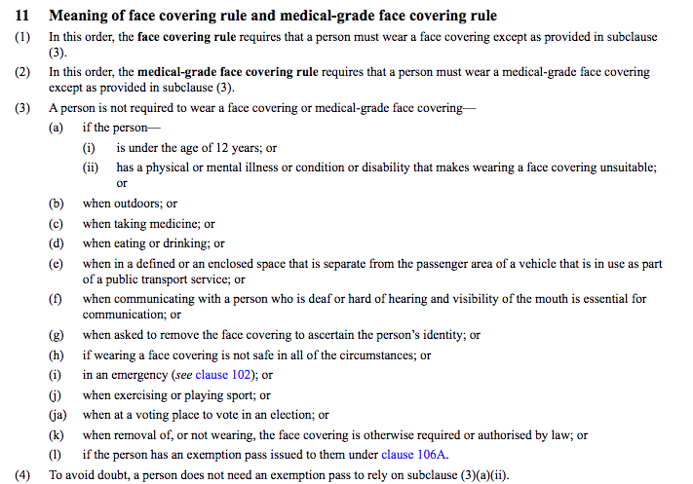

Everyone required to wear a face covering, whether on school buses or not, can still qualify for any of the exemptions listed above.

The likely main ground for an exemption will be that your child has a condition making it unsuitable, unsafe, difficult or not possible for them to wear a face covering. Condition/s are not defined but a non-exhaustive list of conditions that people have found make wearing a face covering unsuitable includes:

- shortness of breath  - asthma  - bronchitis  - auditory processing disorder | - stress  - feelings of anxiety  - deafness  - wearing of glasses | - PTSD  - facial hair  - skin irritation

Disability is defined in section 21(1)(h) of the Human Rights Act 1993 as:
- physical disability or impairment:
- physical illness:
- psychiatric illness:
- intellectual or psychological disability or impairment:
- any other loss or abnormality of psychological, physiological, or anatomical structure or function:
- reliance on a guide dog, wheelchair, or other remedial means:
- the presence in the body of organisms capable of causing illness:

Your child should not feel bad because they are unable to wear a face covering. If they have a reason for not doing so as per the above exemptions, then they should feel comfortable in their position.

Government issued exemption cards

In early April 2022, the MOH bought in a mask exemption called a “Communication Card”. These cards are the same as the ones issued by the Disabled Persons Assembly (but now specifying reasons). The MOH website states that:

“A Communication Card has been developed for you to show to transport operators, retailers and service providers. These make it easier to explain that a face mask is unsuitable for you. There is no legal requirement to carry a Communication Card, though many choose to do so.”
https://www.health.govt.nz/covid-19-novel-coronavirus/covid-19-health-advice-public/covid-19-use-face-masks-community/covid-19-advice-people-who-are-unable-wear-face-mask

The Communication Card was available until 30 May 2022 and is still valid.

From the beginning of June 2022, the MOH bought in a personalised mask exemption called a “Face Mask Exemption Pass”. The Face Mask Exemption Pass
provides conclusive evidence that the holder is exempt under law from wearing a face mask. Because the pass is recognised in law, people with a Communication Card are encouraged to apply for a Face Mask Exemption Pass. For further details and how to apply for a Face Mask Exemption Pass, see:
https://www.health.govt.nz/covid-19-novel-coronavirus/covid-19-health-advice-public/covid-19-use-face-masks-community/covid-19-advice-people-who-have-difficulties-wearing-face-mask

HOW TO USE THIS LETTER?

- Read the letter carefully so that you understand what you are sending – this letter is your letter.
- The points you need to complete or closely consider for your situation are highlighted in yellow. Keep this information factual and do not hesitate to get it checked by a friend, colleague or family member.
- This letter is only to be used in the situation where you are writing to the Principal and/or Board of Trustees at your child's school about the recent edict about masks in schools. If this letter does not apply to your situation, then go to https://voicesforfreedom.co.nz/resources for other mask exemption template letters.
- Do not forget to include your email in the letter so your child's Principal knows where best to respond to you in writing.
- Sign off the letter.
- Print or email the letter – make sure you keep a copy. DO NOT include the first 5 instruction pages with the letter.

Your principal or board of trustees may respond to this letter, and if they do, then you will need to consider their response, and may need to obtain advice specific to your situation.
Dear NAME TEACHER

How are you?

I am writing to let you know that as a consequence of the recent order changes, face coverings are no longer required to be worn at school (just on school buses).

I understand the school is requiring face masks to continue to be used.

I am letting you know that NAME CHILD is exempt from wearing a mask.

The grounds for exemptions are specified in the Traffic Light Order and include:

For your general information, conditions are not defined in the Order, but a non-exhaustive list of conditions that have been found to make wearing a face covering unsuitable includes:
- shortness of breath
- asthma
- bronchitis
- auditory processing disorder
- stress
- feelings of anxiety
- deafness
- blood noses
- wearing of glasses
- PTSD
- skin irritation
With respect to my child’s exemption an exemption card or pass is not required. Face covering exemptions are self-governing and must be respected (clause 11(4) of the Order).

In any event, child’s name has a Communication Card/ Face Covering Exemption Card (clause 106A of the Order), which confirms that it is not safe, unsuitable or possible for them to wear a face covering. They should be treated no differently as a consequence. To do so is discrimination and possibly bullying.

This is a difficult time for us all and we thank you and the school for providing the necessary support. I also trust that you will ensure the children in your class understand it is acceptable for one of their classmates not to be wearing a mask, and to treat him/her with respect. If any child makes enquiries, they should also be made aware of their own rights in this regard.

Yours sincerely,
PARENT NAME

